- \(…)\Strip transfer\Strip infeed-Unit C
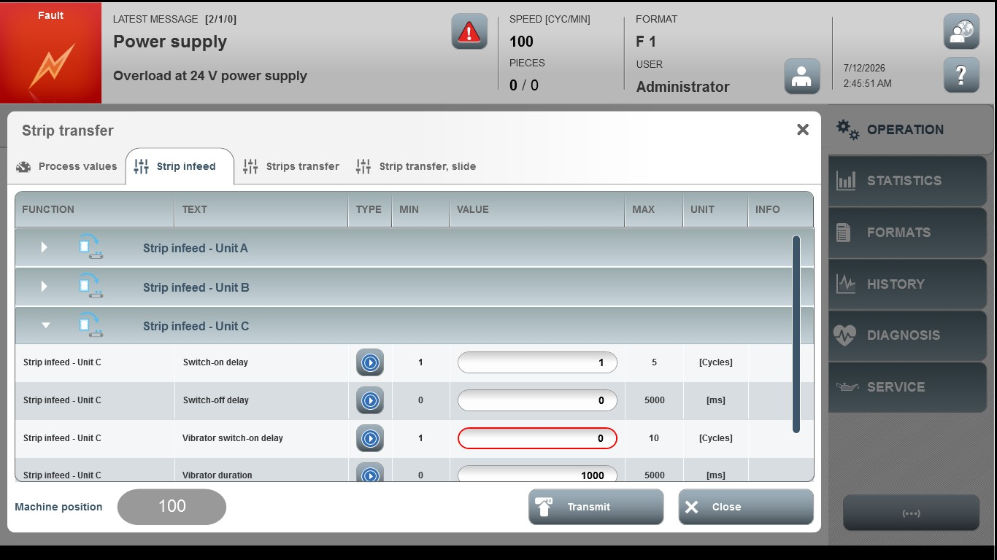
Acceptance criterion | Limits | Pass / Fail: Dev-No. | Date | Initials
Screen matches screenshot | N / A
Switch-on delay | 1…5
Switch-off delay | 0…5000
Vibrator switch-on delay | 1…10
Vibrator duration | 0…5000

